|  |
| --- |
| Technical Milestone 3 |
| Dylan StoneApplied Research Project 1December 15, 2016 |

For my third milestone I have designed and milled a PCB for use in my final project. This board connects to the GPIO header of the Raspberry Pi and passes all of the pins through the board. I connected 6 resistors and LEDs to GPIO Pins so they can be used in the programs on the Pi, and I included a header to connect up to 4 temperature sensors in parallel. This will allow temperature sensors to be easily connected to the Raspberry Pi and the LEDs can be used for whatever is appropriate. This will be very useful as it does not limit any features of the Raspberry Pi, but it is overall easier to connect to, and the board will be very effective for my project. I have included pictures of the board design and milled board on the next two pages.

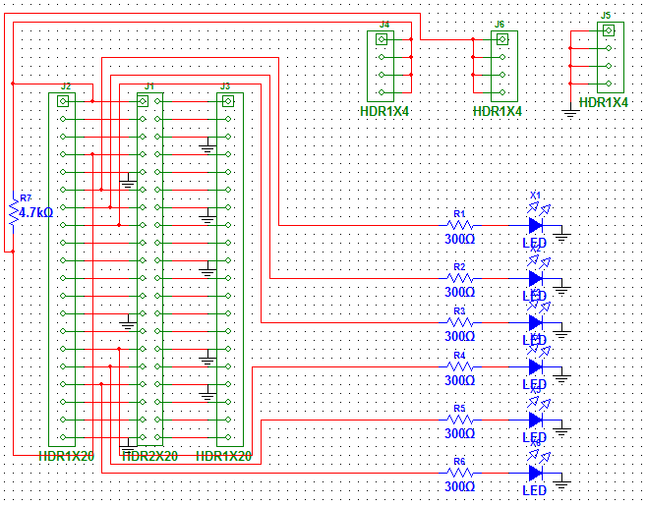

Figure

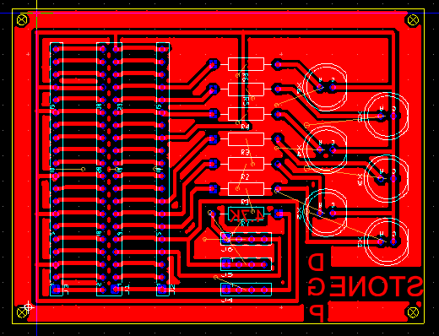

Figure

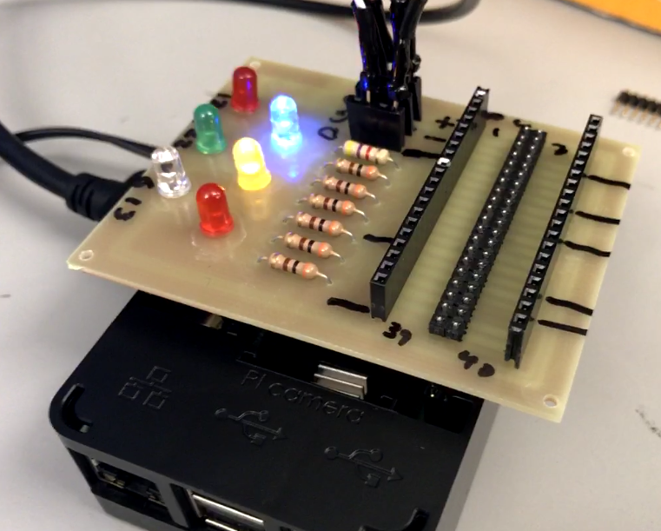

Figure

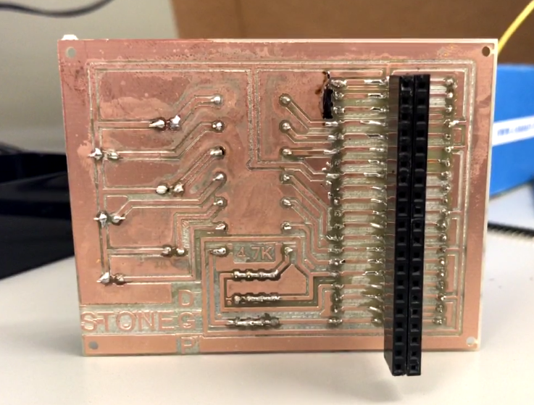

Figure